$$\begin{aligned}з\text{адача 1} \\ m_{1}a={\text{T-m}}_{1}g \\ {\text{-m}}_{2}a=T−m_{2}g \\ a=\frac{m_{2}{\text{-m}}_{1}}{m_{2}+m_{1}}g \\ m_{2}=m_{1}\frac{g+a}{g−a}=1,4\text{кг}∗\frac{9,\text{81}+3,\text{27}}{9,\text{81}−3,\text{27}}=2,8\text{кг} \\ T=\frac{2m_{1}m_{2}}{m_{1}+m_{2}}g=\frac{2∗1,4∗2,8}{1,4+2,8}∗9,\text{81}H=\text{18,312 H} \\ t=\frac{v}{a}=\frac{6,5}{3,\text{27}}\text{сек}=\text{1,987767584 сек }\text{\sim }\text{2 сек} \\ S=h=\frac{{\text{at}}^{2}}{2}=\frac{{\text{3,27*2}}^{2}}{2}=\text{6,54 м}\end{aligned}$$ | $$\begin{aligned}з\text{адача 2} \\ {\text{-m}}_{1}a={\text{T-m}}_{1}g \\ m_{2}a=T−m_{2}g \\ a=\frac{m_{1}{\text{-m}}_{2}}{m_{2}+m_{1}}g \\ m_{2}=m_{1}\frac{g−a}{g+a}=1,4\text{кг}∗\frac{9,\text{81}−3,\text{27}}{9,\text{81}+3,\text{27}}=0,7\text{кг} \\ T=\frac{2m_{1}m_{2}}{m_{1}+m_{2}}g=\frac{2∗1,4∗0,7}{1,4+0,7}∗9,\text{81}H=\text{9,156 H} \\ t=\frac{v}{a}=\frac{6,5}{3,\text{27}}\text{сек}=\text{1,987767584 сек }\text{\sim }\text{2 сек} \\ S=h=\frac{{\text{at}}^{2}}{2}=\frac{{\text{3,27*2}}^{2}}{2}=\text{6,54 м}\end{aligned}$$
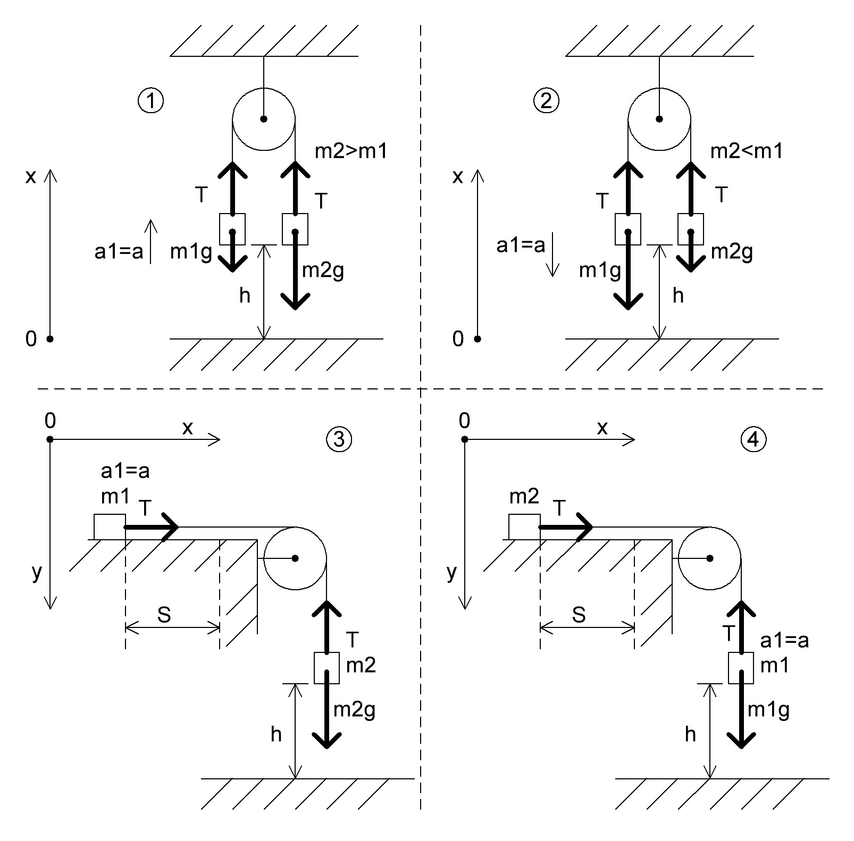 ____
$$\begin{aligned}з\text{адача 3} \\ m_{1}a=T=\text{1,4*3,27 Н}=\text{4,578 H} \\ m_{2}a=m_{2}\text{g-T} \\ m_{2}=\frac{T}{g−a}=\frac{4,\text{578}}{9,\text{81}−3,\text{27}}\text{кг}=0,7\text{кг} \\ t=\frac{v}{a}=\frac{6,5}{3,\text{27}}\text{сек}=\text{1,987767584 сек }\text{\sim }\text{2 сек} \\ S=h=\frac{{\text{at}}^{2}}{2}=\frac{{\text{3,27*2}}^{2}}{2}=\text{6,54 м}\end{aligned}$$ | $$\begin{aligned}з\text{адача 4} \\ m_{2}a=T \\ m_{1}a=m_{1}\text{g-T} \\ T=m_{1}(g−a)=1,4∗(9,\text{81}−3,\text{27})Н=\text{9,156H} \\ m_{2}=\frac{T}{a}=\frac{\text{9,156}}{3,\text{27}}\text{кг}=2,8\text{кг} \\ t=\frac{v}{a}=\frac{6,5}{3,\text{27}}\text{сек}=\text{1,987767584 сек }\text{\sim }\text{2 сек} \\ S=h=\frac{{\text{at}}^{2}}{2}=\frac{{\text{3,27*2}}^{2}}{2}=\text{6,54 м}\end{aligned}$$

