В номерах 350, 351, 352 решить по одному любому примеру
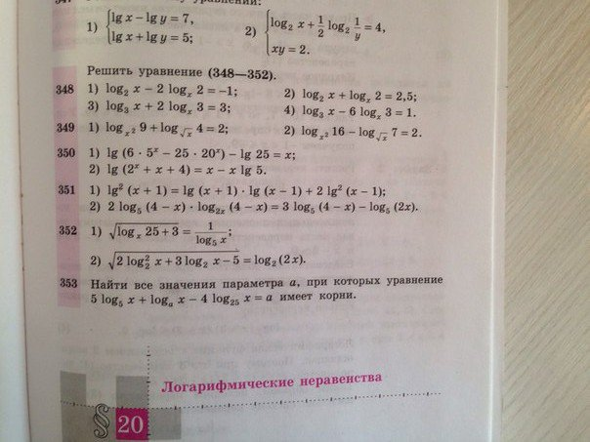
$$\begin{aligned}\text{lg}\left(6⋅5^{x}−\text{25}⋅{\text{20}}^{x}\right)−\text{lg}\text{25}=x\text{.} \\ \text{ОДЗ}: 6⋅5^{x}−\text{25}⋅{\text{20}}^{x}>0 \\ 6⋅5^{x}>\text{25}⋅{\text{20}}^{x}|:\text{25}⋅{\text{20}}^{x}≠0 \\ \frac{6⋅5^{x}}{\text{25}⋅{\text{20}}^{x}}>\frac{\text{25}⋅{\text{20}}^{x}}{\text{25}⋅{\text{20}}^{x}}, \frac{6⋅5^{x}}{\text{25}⋅{\text{20}}^{x}}>1, \frac{6}{\text{25}}⋅{\left(\frac{5}{\text{20}}\right)}^{x}>1, {\left(\frac{1}{4}\right)}^{x}>1:\frac{6}{\text{25}} \\ {\left(\frac{1}{4}\right)}^{x}>\frac{\text{25}}{6}\text{.} \\ \text{прологарифмируем} \text{обе} \text{части} \text{неравенства} \text{по} \text{основанию} \frac{1}{4}\text{.} \\ a=\frac{1}{4}, 0<\frac{1}{4}<1\text{.}\text{знак} \text{неравнества} \text{меняем} \\ {\text{log}}_{\frac{1}{4}}{\left(\frac{1}{4}\right)}^{x}<{\text{log}}_{\frac{1}{4}}\frac{\text{25}}{6}\text{.} x<{\text{log}}_{\frac{1}{4}}\frac{\text{25}}{6}\text{.} x<{\text{log}}_{{\left(\frac{1}{2}\right)}^{2}}\frac{\text{25}}{6}, x<\frac{1}{2}⋅{\text{log}}_{\left(\frac{1}{2}\right)}\frac{\text{25}}{6} \\ x<{\text{log}}_{\left(\frac{1}{2}\right)}{\left(\frac{\text{25}}{6}\right)}^{\frac{1}{2}}, x<{\text{log}}_{\left(\frac{1}{2}\right)}\sqrt{\frac{\text{25}}{6}} \\ x=\text{lg}{\text{10}}^{x} \\ \text{lg}\left(6⋅5^{x}−\text{25}⋅{\text{20}}^{x}\right)−\text{lg}\text{25}=\text{lg}{\text{10}}^{x} \\ \text{lg}\left(6⋅5^{x}−\text{25}⋅{\text{20}}^{x}\right)−\text{lg}{\text{10}}^{x}=\text{lg}\text{25} \\ \text{lg}\frac{6⋅5^{x}−\text{25}⋅{\text{20}}^{x}}{{\text{10}}^{x}}=\text{lg}\text{25} \\ \frac{6⋅5^{x}−\text{25}⋅{\text{20}}^{x}}{{\text{10}}^{x}}=\text{25}, \frac{6⋅5^{x}}{{\text{10}}^{x}}−\frac{\text{25}⋅{\text{20}}^{x}}{{\text{10}}^{x}}=\text{25} \\ 6⋅\frac{5^{x}}{{\text{10}}^{x}}−\text{25}⋅\frac{{\text{20}}^{x}}{{\text{10}}^{x}}=\text{25}, 6⋅{\left(\frac{5}{\text{10}}\right)}^{x}−\text{25}⋅{\left(\frac{\text{20}}{\text{10}}\right)}^{x}=\text{25} \\ 6⋅{\left(\frac{1}{2}\right)}^{x}−\text{25}⋅{\left(\frac{2}{1}\right)}^{x}=\text{25}, \text{замена} \text{переменных}: {\left(\frac{1}{2}\right)}^{x}=t, t>0 \\ 6⋅t−\text{25}⋅\frac{1}{t}=\text{25}|⋅t\text{.} 6t^{2}−\text{25}t−\text{25}=0 \\ D=\text{1225} \\ t_{1,2}=\frac{\text{25}±\text{35}}{\text{12}}, t_{1}=5, t_{2}=−\frac{\text{10}}{\text{12}}, −\frac{\text{10}}{\text{12}}<0 \text{постороннийкорень} \\ \text{обратная} \text{замена}: t_{1}=5, {\left(\frac{1}{2}\right)}^{x}=5 {\text{log}}_{\frac{1}{2}}{\left(\frac{1}{2}\right)}^{x}={\text{log}}_{\frac{1}{2}}5 \\ x⋅{\text{log}}_{\frac{1}{2}}{\left(\frac{1}{2}\right)}^{x}={\text{log}}_{\frac{1}{2}}5\text{.} x={\text{log}}_{\frac{1}{2}}5\text{.} {\text{log}}_{\frac{1}{2}}5<{\text{log}}_{\left(\frac{1}{2}\right)}\sqrt{\frac{\text{25}}{6}} \\ \text{ответ}: x={\text{log}}_{\frac{1}{2}}5\end{aligned}$$
$$\begin{aligned}{\text{lg}}^{2}\left(x+1\right)=\text{lg}\left(x+1\right)⋅\text{lg}\left(x−1\right)+2{\text{lg}}^{2}\left(x−1\right) \\ \text{ОДЗ}: \\ \end{aligned}\begin{aligned}\left\{x+1>0 | \right.\end{aligned}$$

