$$y=2x^{2}$$  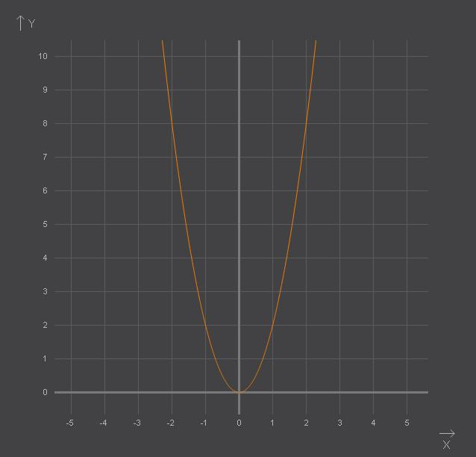 | $$y=\frac{3}{x}−1$$  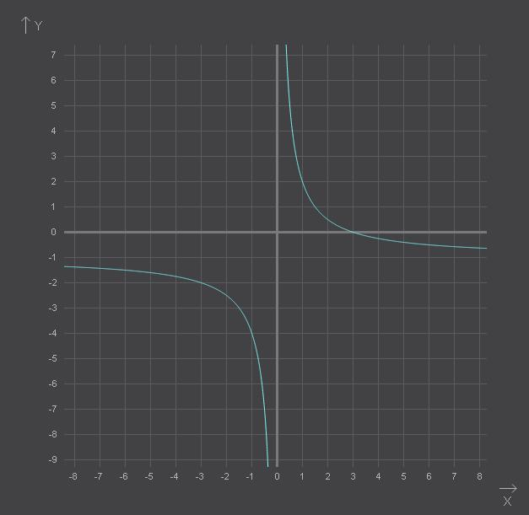
$$y=−\frac{4}{x}$$  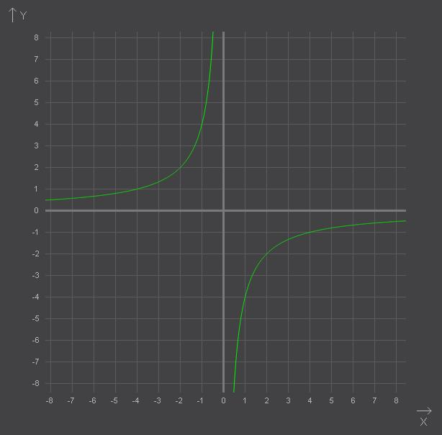 | $$y=−{\left(x+1\right)}^{2}$$  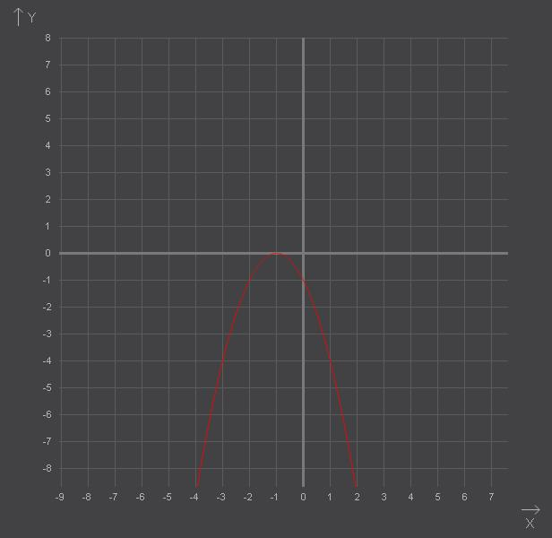
$$y=−\frac{1}{3}x^{2}$$  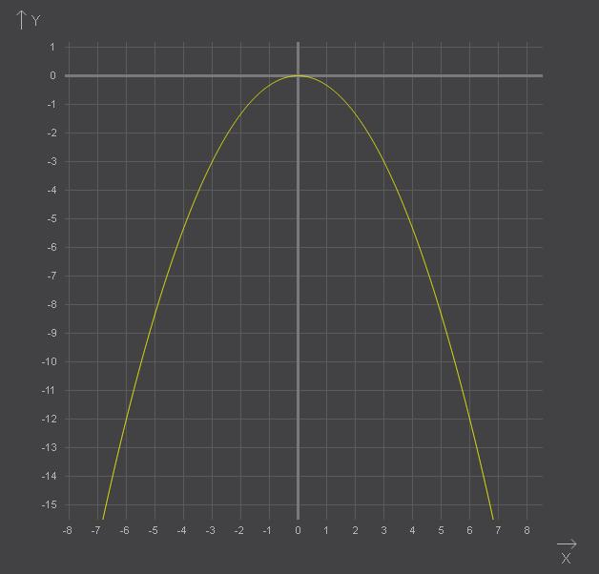 | $$y=−\frac{6}{x−2}$$  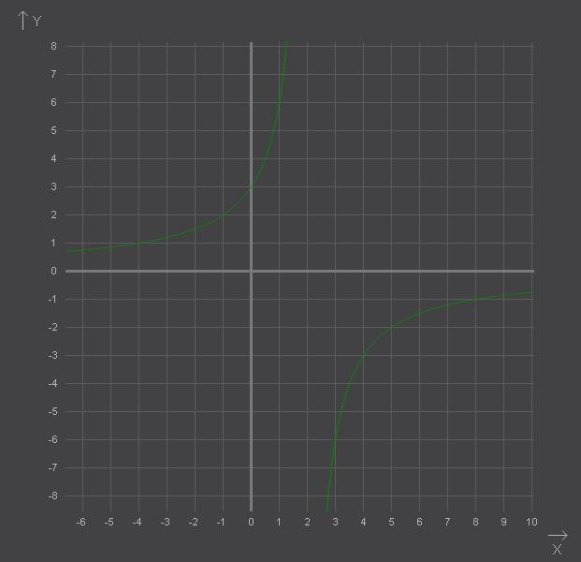
$$y=\frac{8}{x}$$  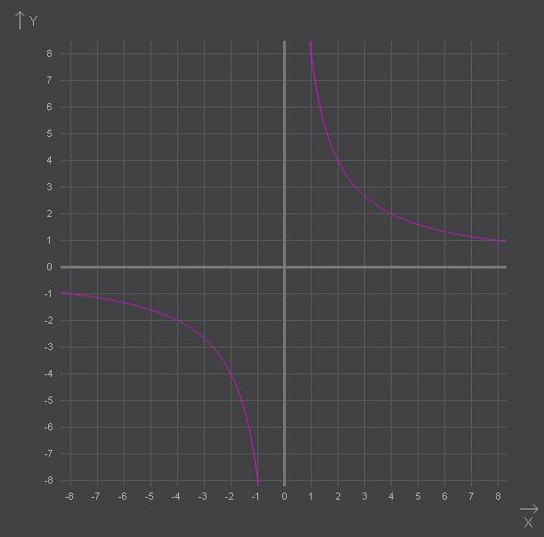 | $$y=3x^{2}−4$$  