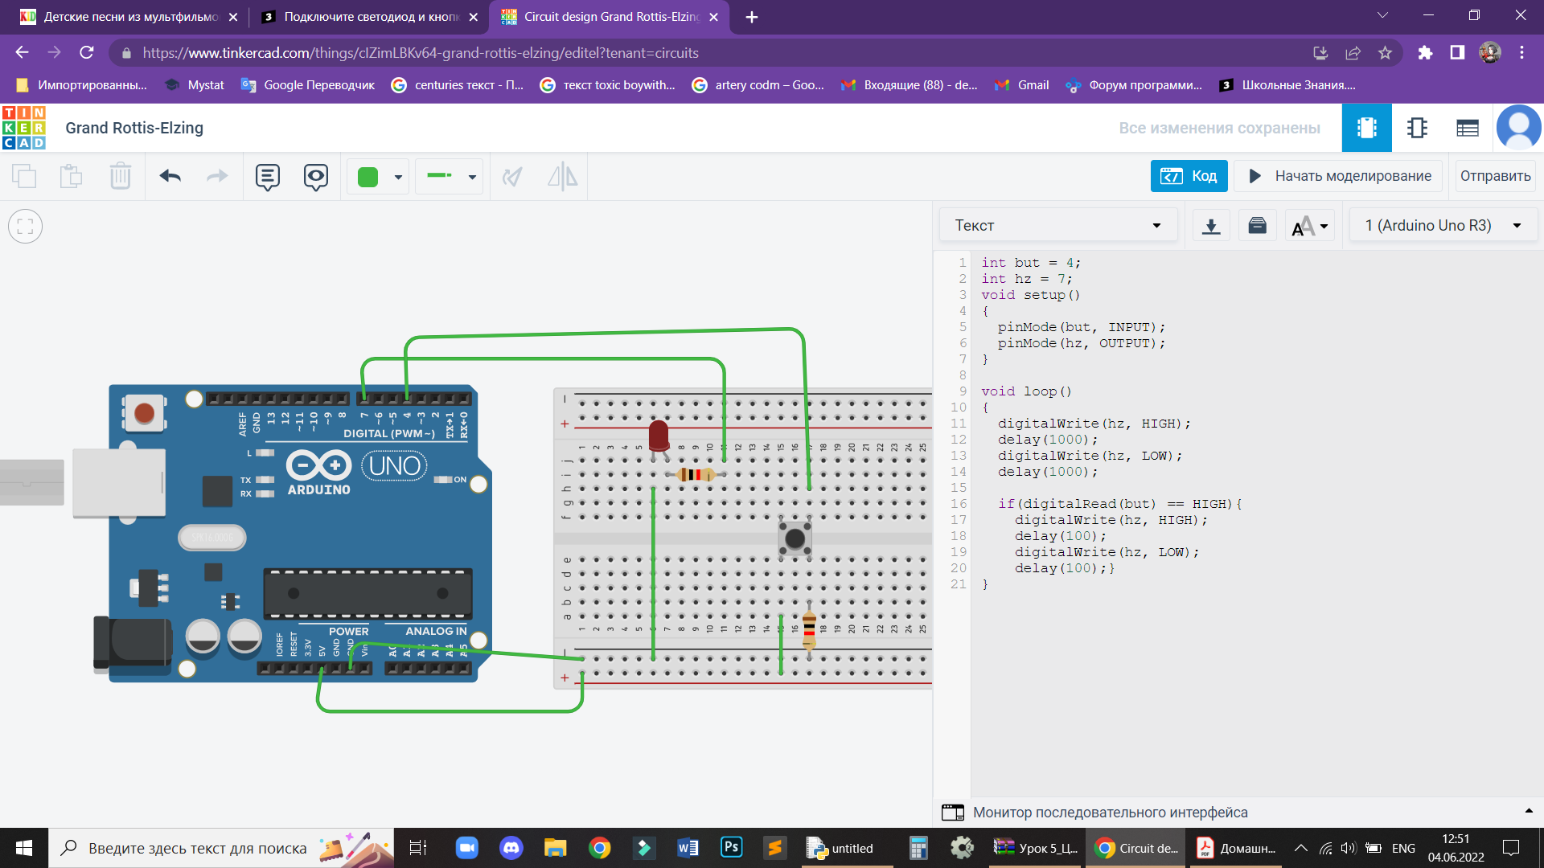int but = 4;

int hz = 7;

void setup()

{

pinMode(but, INPUT);

pinMode(hz, OUTPUT);

}

void loop()

{

digitalWrite(hz, HIGH);

delay(1000);

digitalWrite(hz, LOW);

delay(1000);

if(digitalRead(but) == HIGH){

digitalWrite(hz, HIGH);

delay(100);

digitalWrite(hz, LOW);

delay(100);}

}