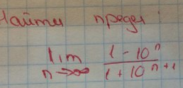

$$\begin{aligned} \underset{n→∞}{\text{lim}}\frac{1−{\text{10}}^{n}}{1+{\text{10}}^{n+1}}=\frac{∞}{∞} \\ \underset{n→∞}{\text{lim}}\frac{\frac{1}{{\text{10}}^{n+1}}−\frac{{\text{10}}^{n}}{{\text{10}}^{n+1}}}{\frac{1}{{\text{10}}^{n+1}}+\frac{{\text{10}}^{n+1}}{{\text{10}}^{n+1}}}=\underset{n→∞}{\text{lim}}\frac{\frac{1}{{\text{10}}^{n+1}}−\frac{1}{\text{10}}}{\frac{1}{{\text{10}}^{n+1}}+1}=\frac{\frac{1}{\text{10}}}{1}=−\frac{1}{\text{10}}=−0,1 \\ \frac{1}{{\text{10}}^{n+1}}→0, \text{при} n→∞\end{aligned}$$

