**Tasks for the Summative Assessment for the term 3**

**Name: __________________________________________________**

**Duration:** 35 minutes

**Use of English**

**Task 1** Complete the table.

|  |  |
| --- | --- |
| **Present** | **Past** |
| finish |  |
| eat |  |
| play |  |
| give |  |
| have |  |

**[5]**

**Task 2.** Complete the sentences.

1. Nurlybek ________(have) a great birthday last August.
2. _______________ (he/watch TV) last night?
3. Bella ______________ (not/swim) last summer.
4. We all _____________(dance) at Dana’s party.
5. I__________ (do) my homework yesterday. [5]

**Reading**

**Task 3.** Read and write.

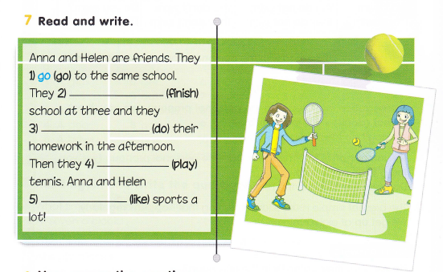

Anna and Helen are friends.

Yesterday they ______ (have) a nice time.

They__________ (finish) school at three.

Then they ______ (visit) a park after school.

They _______(play) tennis and _______ (eat) ice cream.

It was great!

**[5]**

**[15]**