area between | y = 1+2.5 x^2\ny = -9+10 x | domain | 0<=x<=2

 integral_0^2 (10-10 x+2.5 x^2) dx = 6.66667

 integral (2.5 x^2+1-10 x+9) dx = 0.833333 x^3-5 x^2+10 x+constant

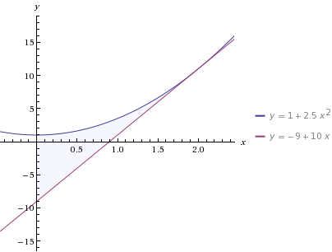

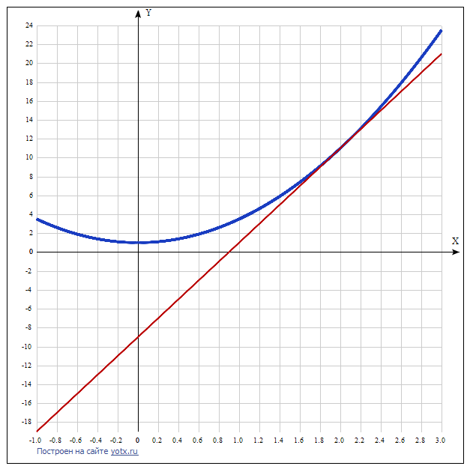

 integral_(-1)^2 (1+x^3) dx = 27\/4~~6.75

 integral (1+x^3) dx = x^4\/4+x+constant

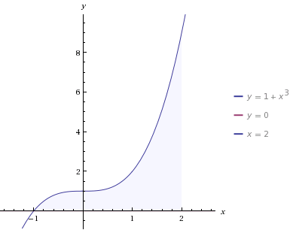и