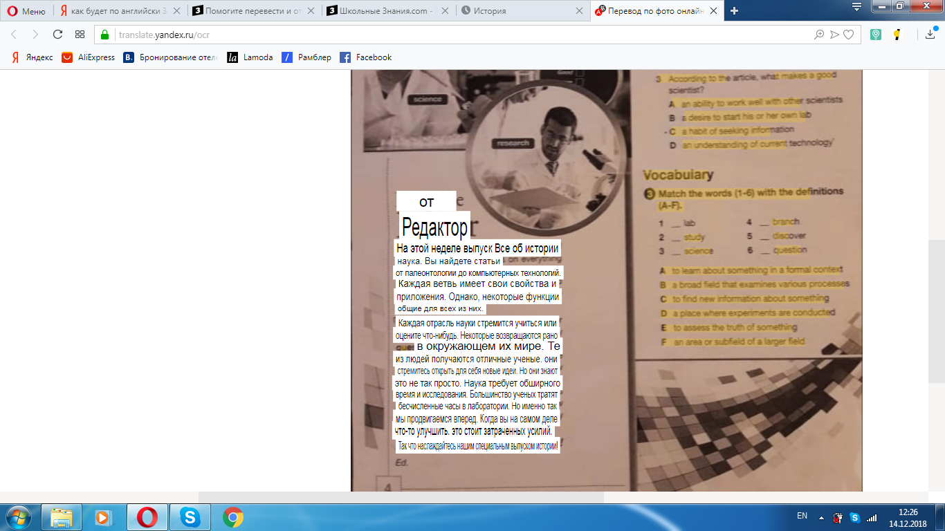[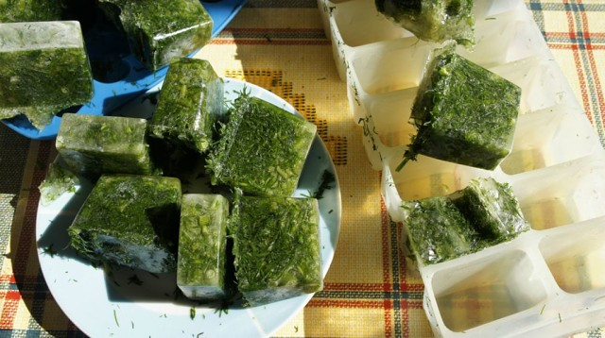](https://ok.ru/dk?cmd=PopLayerPhoto&st.layer.cmd=PopLayerPhotoOuter&st.layer.type=GROUP&st.layer.revNav=off&st.layer.limitedUi=false&st.layer.sphotoIds=836314512534;836314512278;836314512022;836314511766;836314511510&st.layer.showNav=on&st.layer.photoAlbumId=51644847292566&st.layer.epm=off&st.layer.photoId=836314512534&st.layer.opl=off&st.layer.navStartPhotoId=836314512534&st.layer.sbd=off&st.cmd=userMain&st._aid=GroupTopicLayer_openPhotoLayer)

[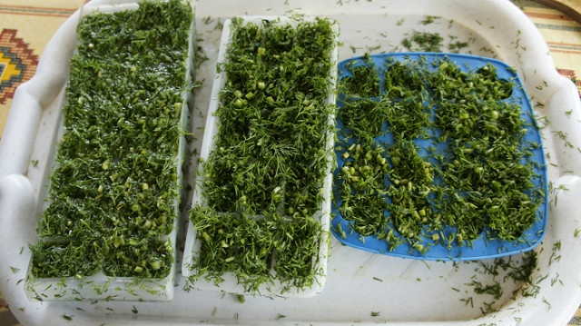](https://ok.ru/dk?cmd=PopLayerPhoto&st.layer.cmd=PopLayerPhotoOuter&st.layer.type=GROUP&st.layer.revNav=off&st.layer.limitedUi=false&st.layer.sphotoIds=836314512534;836314512278;836314512022;836314511766;836314511510&st.layer.showNav=on&st.layer.photoAlbumId=51644847292566&st.layer.epm=off&st.layer.photoId=836314512278&st.layer.opl=off&st.layer.navStartPhotoId=836314512278&st.layer.sbd=off&st.cmd=userMain&st._aid=GroupTopicLayer_openPhotoLayer)

[](https://ok.ru/dk?cmd=PopLayerPhoto&st.layer.cmd=PopLayerPhotoOuter&st.layer.type=GROUP&st.layer.revNav=off&st.layer.limitedUi=false&st.layer.sphotoIds=836314512534;836314512278;836314512022;836314511766;836314511510&st.layer.showNav=on&st.layer.photoAlbumId=51644847292566&st.layer.epm=off&st.layer.photoId=836314512022&st.layer.opl=off&st.layer.navStartPhotoId=836314512022&st.layer.sbd=off&st.cmd=userMain&st._aid=GroupTopicLayer_openPhotoLayer)