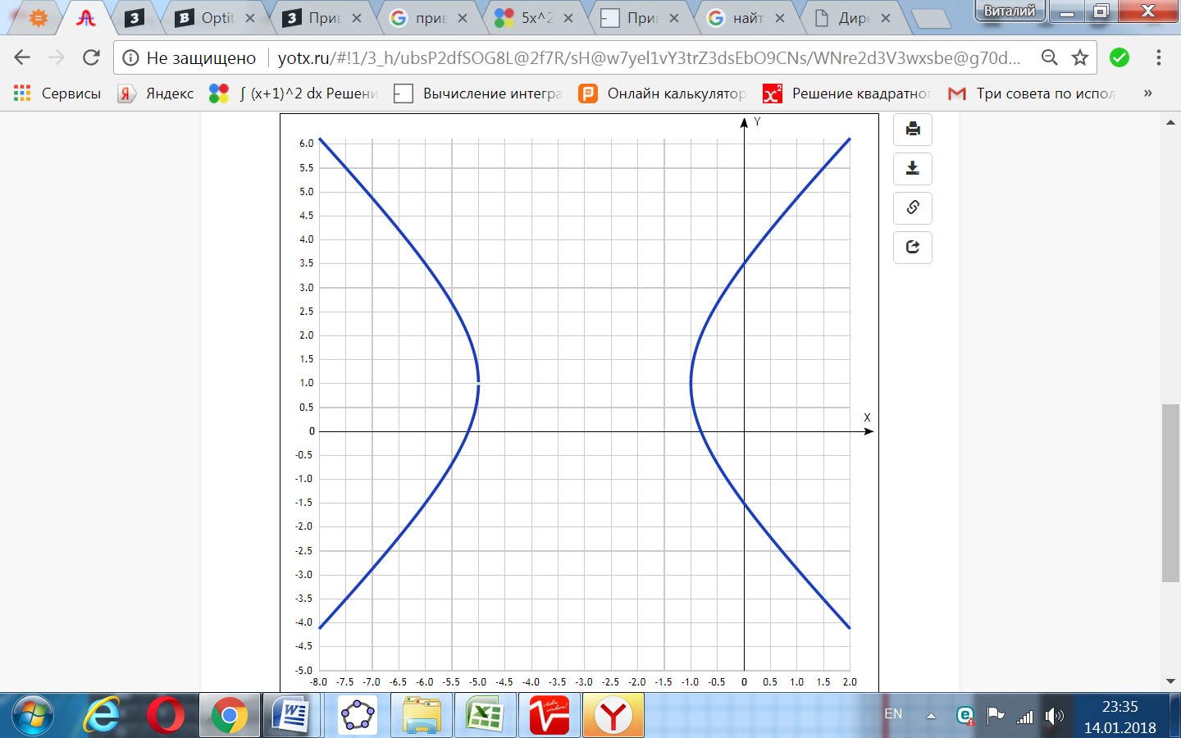

[Таблица точек](javascript:void(0);) (положительная полуплоскость)

|  |  |
| --- | --- |
| **x** | **y** |
| -8.0 | 6.12 |
| -7.5 | 5.51 |
| -7.0 | 4.87 |
| -6.5 | 4.21 |
| -6.0 | 3.5 |
| -5.5 | 2.68 |
| -5.0 | 1 |
| -4.5 | - |
| -4.0 | - |
| -3.5 | - |
| -3.0 | - |
| -2.5 | - |
| -2.0 | - |
| -1.5 | - |
| -1.0 | 1 |
| -0.5 | 2.68 |
| 0 | 3.5 |
| 0.5 | 4.21 |
| 1.0 | 4.87 |
| 1.5 | 5.51 |
| 2.0 | 6.12 |