**1 вариант**

1) http://www5a.wolframalpha.com/Calculate/MSP/MSP1556216gfff692hc5h5i00000h149ibicfggde5i?MSPStoreType=image/gif&s=20&w=204.&h=61.

http://www5a.wolframalpha.com/Calculate/MSP/MSP1561216gfff692hc5h5i000031h883hi6e831g26?MSPStoreType=image/gif&s=20&w=112.&h=18.

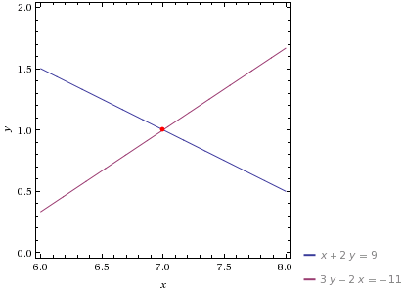

2) 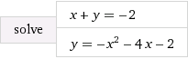

http://www4a.wolframalpha.com/Calculate/MSP/MSP61831chf4egg95ge4ai200002e845i1dh89g7igg?MSPStoreType=image/gif&s=44&w=123.&h=18.

http://www4a.wolframalpha.com/Calculate/MSP/MSP61861chf4egg95ge4ai20000242dhi1c97d26224?MSPStoreType=image/gif&s=44&w=123.&h=18.

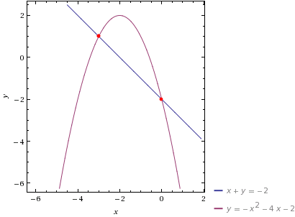

3)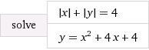

http://www5a.wolframalpha.com/Calculate/MSP/MSP2761f57bgd67hcbc14f00002gaca14bfbb403ai?MSPStoreType=image/gif&s=33&w=189.&h=18. = 1

http://www5a.wolframalpha.com/Calculate/MSP/MSP2791f57bgd67hcbc14f00001b1f677a0ec2h921?MSPStoreType=image/gif&s=33&w=178.&h=18. = 4

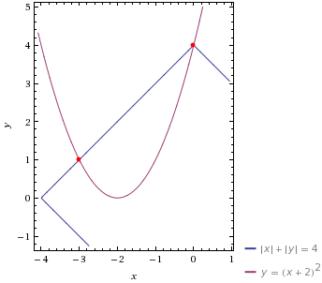

4)http://www4b.wolframalpha.com/Calculate/MSP/MSP37031ffhg0dh79b5a7fi000058i4ge09bg595126?MSPStoreType=image/gif&s=29&w=173.&h=51.

http://www4b.wolframalpha.com/Calculate/MSP/MSP10971dfd853507731fb20000609g4df98h0agace?MSPStoreType=image/gif&s=14&w=47.&h=18.

