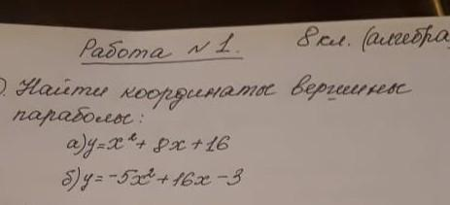

|  |  |
| --- | --- |
| |  | | --- | | 1. ***1 способ:*** | |

|  |
| --- |
| ***2 способ:*** |

|  |
| --- |
| ***б) $y=-5x^{2}+16x-3$*** |

$$x_{в}=\frac{16}{10}=1,6$$

$$y_{в}=-5*2,56+16*2,56-3=25,16$$