Time | F/nf | formula | 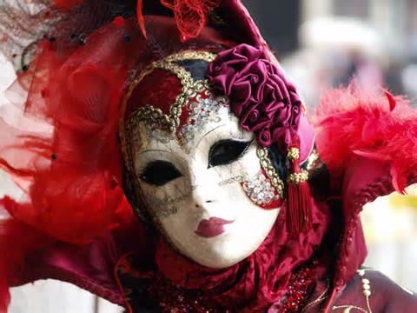  Ten years ago, my husband and I 1__________________(buy) a house in Venice, Italy. Since that time, I 2_______________________(come) to know and love the residents of Venice and their culture. Each day brings some new information about the region which I 3____________________(share) on my blog.  February 1, 2013 by The Busy Beet Europe Trips: Venice Carnival  Ciao friends! Hello from my new home in Florence, Italy.  I 4____________(be) here for a week now and I’m already very much in love. There is so much to tell but this post 5__________________(be) specifically about my experience this weekend at the opening ceremonies of Carnival in Venice! I 6___________________(already/see) Festa Veneziana and a water parade of unique boats. I 7__________________(taste) wine and traditional Venetian Carnival specialities for FREE!  I’ve noticed that Italians 8____________________(love) to share everything – food and wine of course, but also their time. The first day of the Carnival 9__________________(be) amazing! We finished the day by taking a water taxi down the Grand Canal and viewing a glass blowing demonstration at the Vecchia Murano Glass factory. If you have the opportunity, you must see Venice – at least once! You 10_________________(never/forget) its beauty and charm.
1
2
3
4
5
6
7
8
9
10

http://www.youtube.com/watch?v=n7nYvQCsDNY
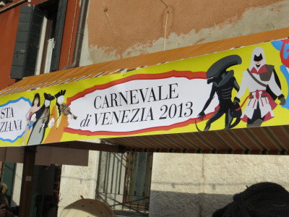
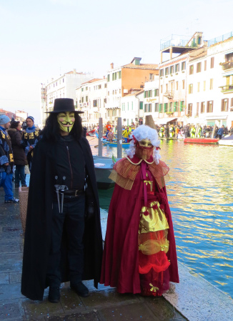
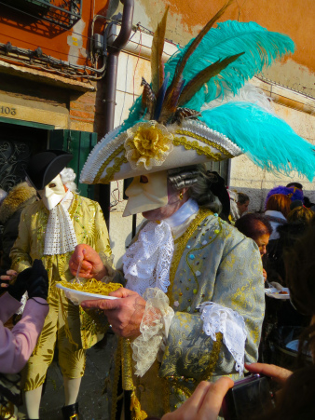
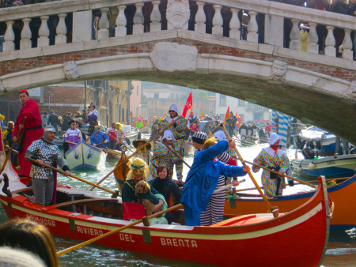
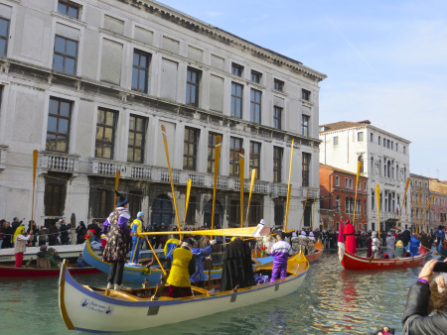
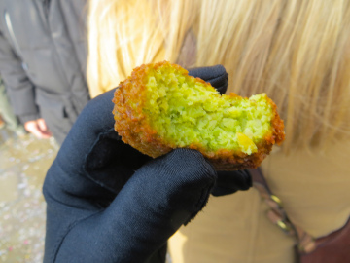
One of the first things I tried, delicious falafel! Crispy outside and moist inside, these little bites were jam packed with flavor and were the perfect appetizer!
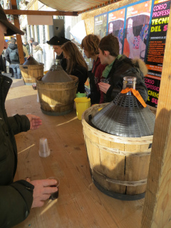
These jugs were full of some of the best red and white wines I’ve ever tasted.
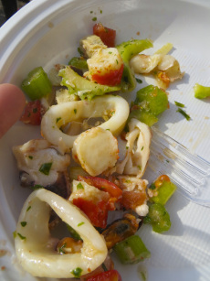
Pieces of Lobster, calamari, clams, etc. with bits of celery and peppers. Can’t get much better!
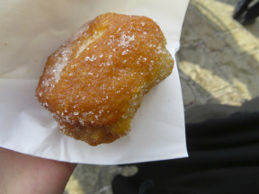
Just look at this Zeppole….need I say more?
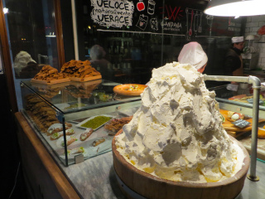
cannoli cream mountain and fresh shells

