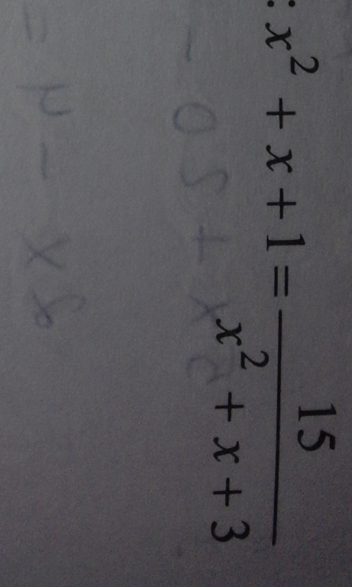
$$\begin{aligned}x^{2}+x+1=\frac{\text{15}}{x^{2}+x+3} \\ \left(x^{2}+x+1\right)=\frac{\text{15}}{\left(x^{2}+x+1\right)+2} \\ \text{замена} \text{переменных}: x^{2}+x+1=t, t≠−2 \\ t=\frac{\text{15}}{t+2} \\ t^{2}+2t−\text{15}=0 \\ D=2^{2}−4⋅1⋅\left(−\text{15}\right)=\text{64} \\ t_{1\text{.}2}=\frac{−2±\sqrt{\text{64}}}{2⋅1}=\frac{−2±8}{2} \\ t_{1}=−5, t_{2}=3 \\ \text{обратная} \text{замена}: \\ t_{1}=−5, x^{2}+x+1=−5, x^{2}+x+6=0 \\ D<0\text{.} \text{корней} \text{нет} \\ \\ t_{2}=3, x^{2}+x+1=3\text{.} x^{2}+x−2=0 \\ x_{1}=−2, x_{2}=1\end{aligned}$$

