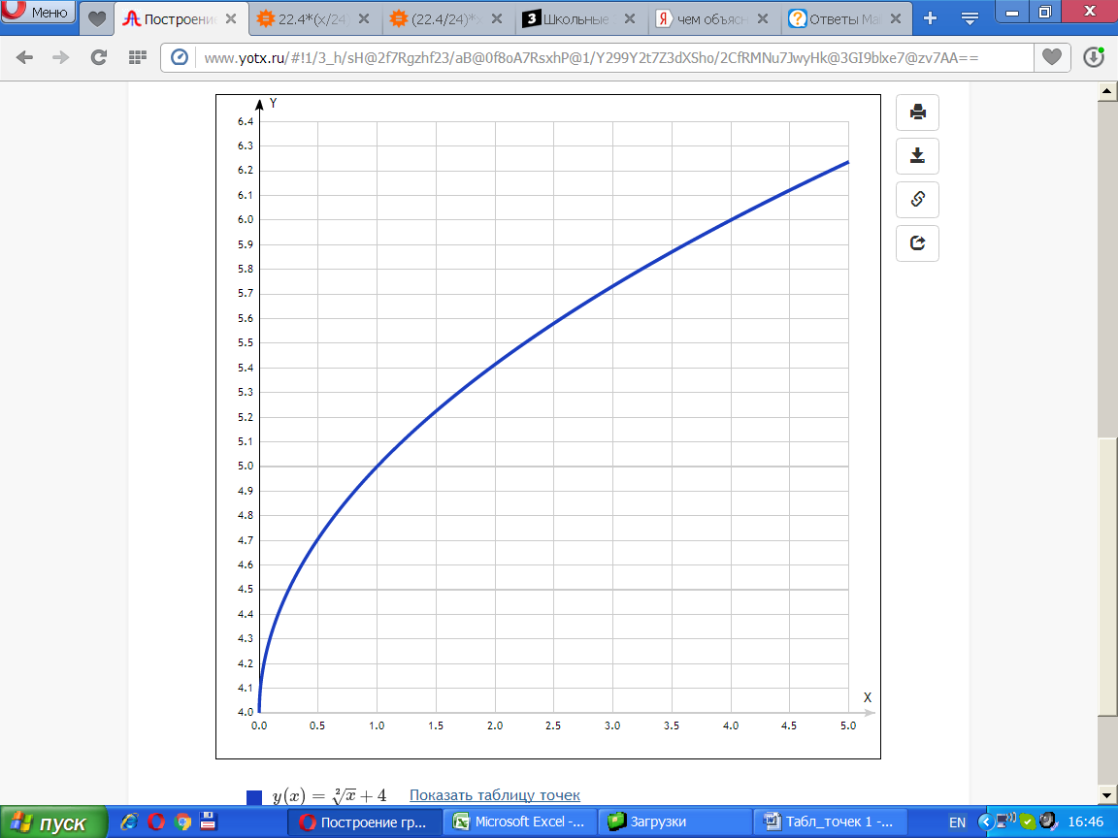

y(x)=√х+4

[Таблица точек](javascript:void(0);)

|  |  |
| --- | --- |
| **x** | **y** |
| 0.0 | 4 |
| 0.5 | 4.71 |
| 1.0 | 5 |
| 1.5 | 5.22 |
| 2.0 | 5.41 |
| 2.5 | 5.58 |
| 3.0 | 5.73 |
| 3.5 | 5.87 |
| 4.0 | 6 |
| 4.5 | 6.12 |
| 5.0 | 6.24 |

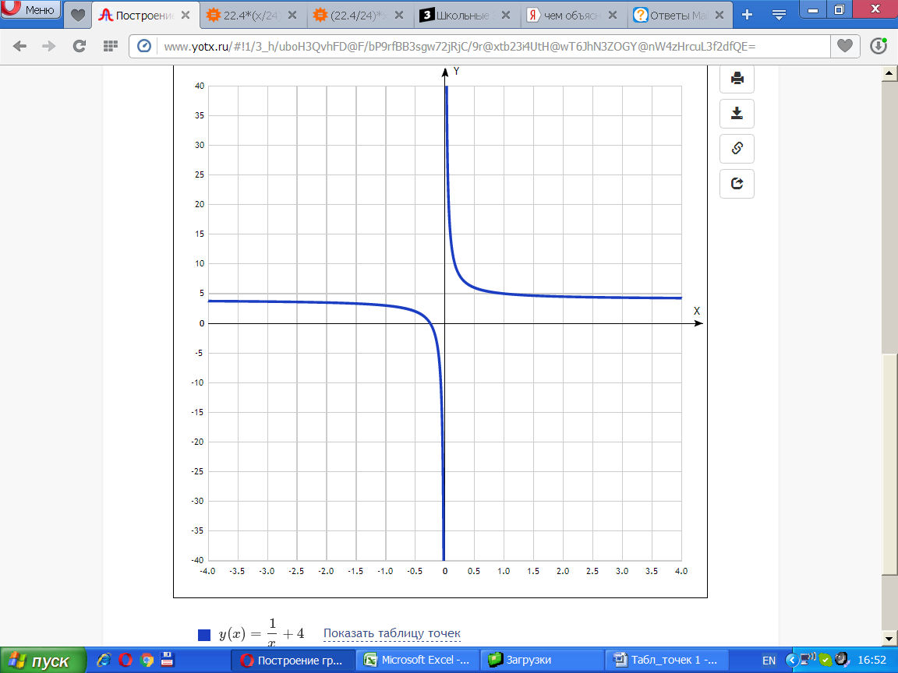

y(x)=1x+4 [Показать таблицу точек](javascript:void(0);)

|  |  |
| --- | --- |
| **x** | **y** |
| -4.0 | 3.8 |
| -3.5 | 3.7 |
| -3.0 | 3.7 |
| -2.5 | 3.6 |
| -2.0 | 3.5 |
| -1.5 | 3.3 |
| -1.0 | 3 |
| -0.5 | 2 |
| 0 | - |
| 0.5 | 6 |
| 1.0 | 5 |
| 1.5 | 4.7 |
| 2.0 | 4.5 |
| 2.5 | 4.4 |
| 3.0 | 4.3 |
| 3.5 | 4.3 |
| 4.0 | 4.3 |