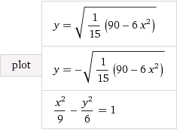

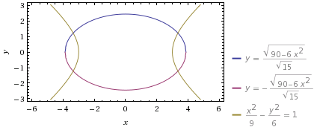

 integral_2^3 (3 x^4+2 x^3)\/x^2 dx = 24

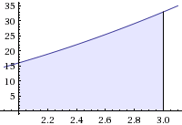

 integral (3 x^4+2 x^3)\/x^2 dx = x^3+x^2+constant

