**SUMMATIVE ASSESSMENT FOR TERM 4**

**Grade 3**

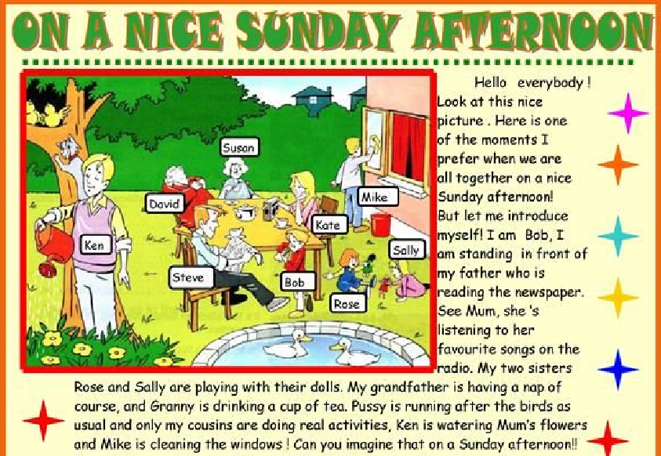

**Task 1. Answer the following questions**

1. Who is speaking? ………………………………………. [1]
2. What is Mike doing? …………………………………… [1]
3. What is Ken doing? …………………………………….. [1]
4. What are the little girls doing? ………………………..... [1]
5. Who is reading the newspaper? ………………………… [1]

**Task 2. Read and circle**

1. Kanat can run very **quick / quickly** [1]
2. This is an **easy / easily** exercise [1]
3. Be **quietly / quite**, please! [1]
4. I am **fish / fishing** [1]
5. That’s **who / why** summer is my favourite season![1]