$$y=\frac{x^{2}+8x+16}{x+3}$$

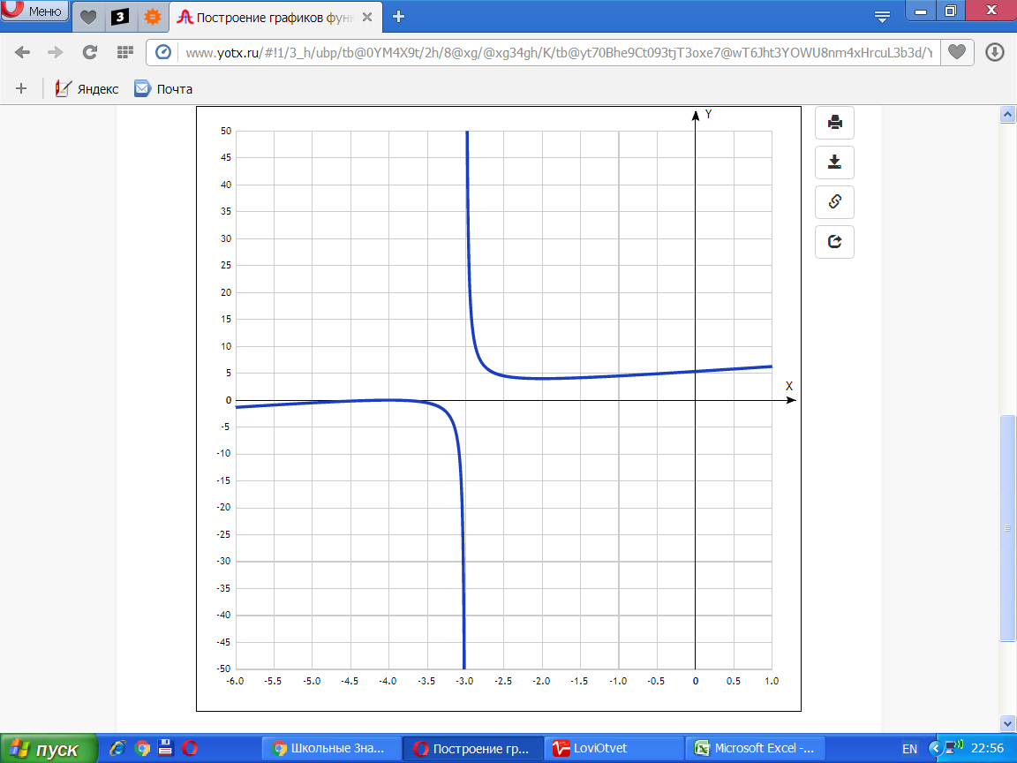

|  |  |
| --- | --- |
| **x** | **y** |
| -6.0 | -1.3 |
| -5.5 | -0.9 |
| -5.0 | -0.5 |
| -4.5 | -0.2 |
| -4.0 | 0 |
| -3.5 | -0.5 |
| -3.0 | - |
| -2.5 | 4.5 |
| -2.0 | 4 |
| -1.5 | 4.2 |
| -1.0 | 4.5 |
| -0.5 | 4.9 |
| 0 | 5.3 |
| 0.5 | 5.8 |
| 1.0 | 6.3 |