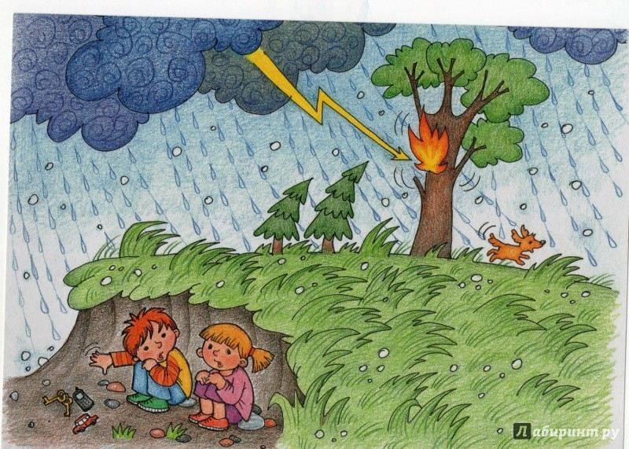 ____________________________________________________________________________________________________________________________________________________________________________

**Задание 2** Рассмотри картинки. Выбери одну. О каком природном явлении ты можешь рассказать по ней? Составь план своего рассказа. Запиши рассказ о природном явлении, используя свой план.



