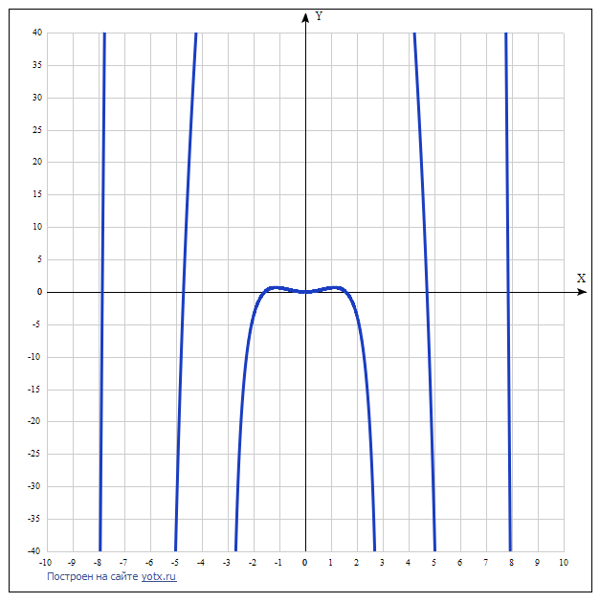

y(x)=x3ctg(x) [Таблица точек](javascript:void(0);)

|  |  |
| --- | --- |
| **x** | **y** |
| -10 | 1542.4 |
| -9 | -1611.7 |
| -8 | -75.3 |
| -7 | 393.6 |
| -6 | -742.3 |
| -5 | -37 |
| -4 | 55.3 |
| -3 | -189.4 |
| -2 | -3.7 |
| -1 | 0.6 |
| 0 | - |
| 1 | 0.6 |
| 2 | -3.7 |
| 3 | -189.4 |
| 4 | 55.3 |
| 5 | -37 |
| 6 | -742.3 |
| 7 | 393.6 |
| 8 | -75.3 |
| 9 | -1611.7 |
| 10 | 1542.4 |