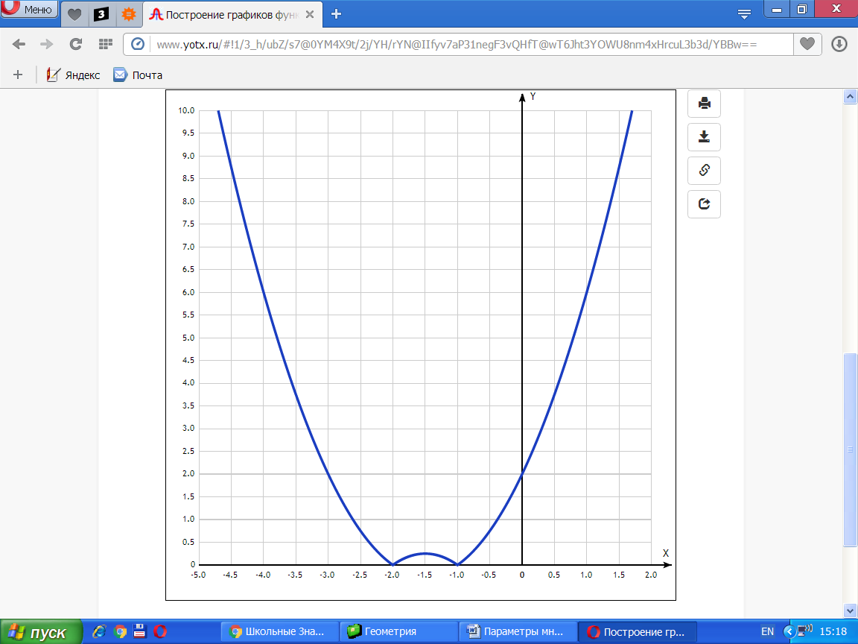

[Таблица точек](javascript:void(0);)

|  |  |
| --- | --- |
| **x** | **y** |
| -5.0 | 12 |
| -4.5 | 8.75 |
| -4.0 | 6 |
| -3.5 | 3.75 |
| -3.0 | 2 |
| -2.5 | 0.75 |
| -2.0 | 0 |
| -1.5 | 0.25 |
| -1.0 | 0 |
| -0.5 | 0.75 |
| 0 | 2 |
| 0.5 | 3.75 |
| 1.0 | 6 |
| 1.5 | 8.75 |
| 2.0 | 12 |