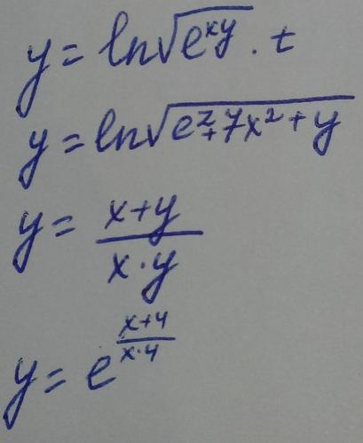
1)
$$\begin{aligned}y=\text{ln}\sqrt{e^{\text{xy}}}∗t \\ \text{dy}=\frac{t}{\sqrt{e^{\text{xy}}}}∗\frac{1}{2\sqrt{e^{\text{xy}}}}∗e^{\text{xy}}∗x∗\text{dy}+\frac{t}{\sqrt{e^{\text{xy}}}}∗\frac{1}{2\sqrt{e^{\text{xy}}}}∗e^{\text{xy}}∗y∗\text{dx}+\text{ln}\sqrt{e^{\text{xy}}}∗\text{dt} \\ \text{dy}=\frac{x}{2}\text{dy}+\frac{y}{2}\text{dx}+\frac{y}{t}∗\text{dt} \\ \left(1−\frac{x}{2}\right)\text{dy}=\frac{y}{2}\text{dx}+\frac{y}{t}∗\text{dt}\end{aligned}$$
2)
$$\begin{aligned}y=\text{ln}\sqrt{e^{z}+7x^{2}+y} \\ \text{dy}=\frac{1}{\sqrt{e^{z}+7x^{2}+y}}∗\frac{1}{2\sqrt{e^{z}+7x^{2}+y}}∗\left(e^{z}\text{dz}+\text{14}\text{xdx}+\text{dy}\right) \\ \text{dy}=\frac{e^{z}\text{dz}+\text{14}\text{xdx}+\text{dy}}{2\left(e^{z}+7x^{2}+y\right)} \\ 2\left(e^{z}+7x^{2}+y\right)\text{dy}=e^{z}\text{dz}+\text{14}\text{xdx}+\text{dy} \\ \left(2e^{z}+\text{14}x^{2}+2y−1\right)\text{dy}=e^{z}\text{dz}+\text{14}\text{xdx}\end{aligned}$$
3)
$$\begin{aligned}y=\frac{x+y}{\text{xy}}=\frac{1}{y}+\frac{1}{x} \\ \text{dy}=−\frac{\text{dy}}{y^{2}}−\frac{\text{dx}}{x^{2}} \\ \left(1+\frac{1}{y^{2}}\right)\text{dy}=−\frac{\text{dx}}{x^{2}}\end{aligned}$$
4)
$$\begin{aligned}y=e^{\frac{x+4}{x∗4}}=e^{\left(\frac{1}{4}+\frac{1}{x}\right)} \\ \text{dy}=e^{\left(\frac{1}{4}+\frac{1}{x}\right)}∗\left(−\frac{\text{dx}}{x^{2}}\right) \\ \frac{\text{dy}}{y}=−\frac{\text{dx}}{x^{2}}\end{aligned}$$

