|  |  |  |  |  |  |  |  |  |  |
| --- | --- | --- | --- | --- | --- | --- | --- | --- | --- |
|  |  |  |  | **1.B** | E | D |  |  |  |
|  |  |  | 2.S | **O** | F | A |  |  |  |
| 3.M | I | R | R | **O** | R |  |  |  |  |
|  |  |  |  | **4.C** | H | A | I | R |  |
|  | 5.D | E | S | **K** |  |  |  |  |  |
|  |  |  | 6.L | **A** | M | P |  |  |  |
|  |  |  |  | **7.S** | H | E | L | F |  |
| 8.C | A | R | P | **E** | T |  |  |  |  |

1. 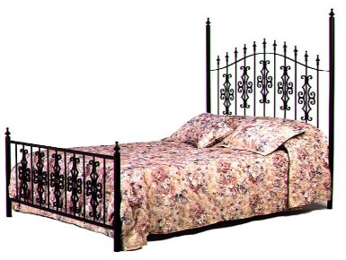 6. 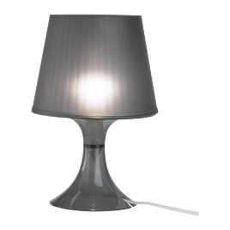
2. 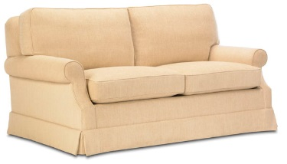 7. 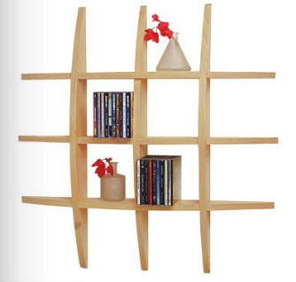
3. 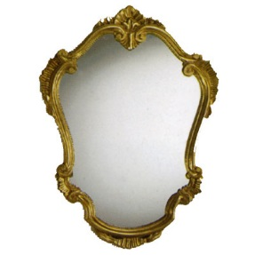 8. 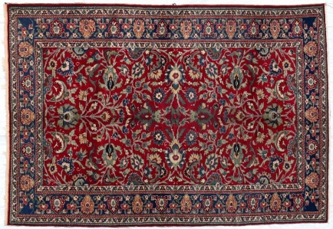
4. 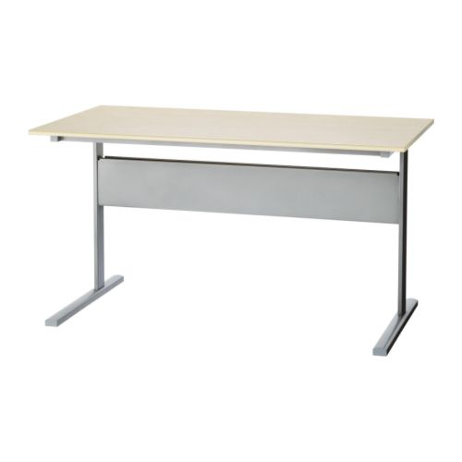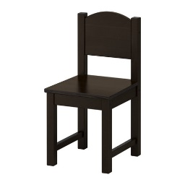5.