у=х3-3х2-1

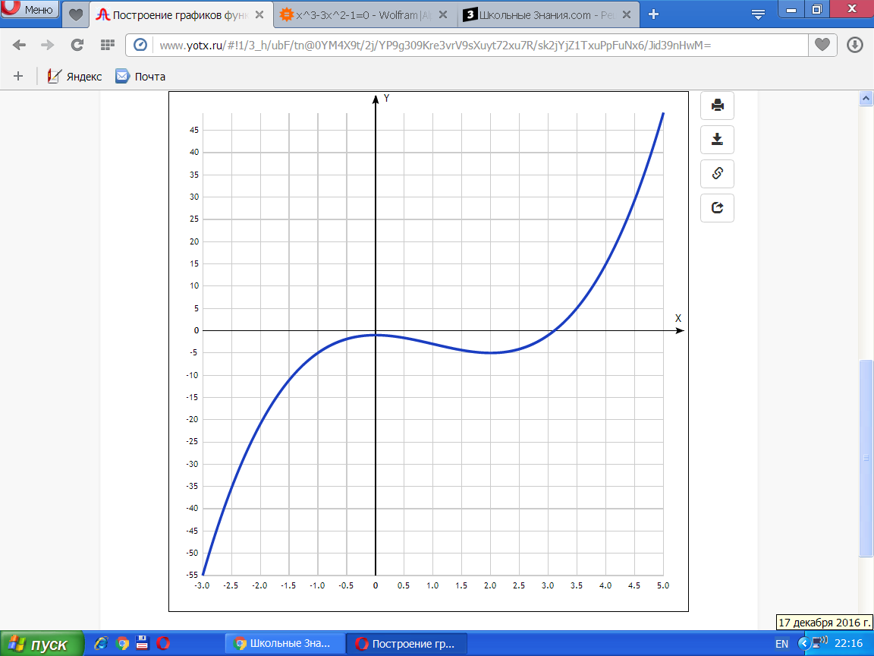

|  |  |
| --- | --- |
| **x** | **y** |
| -3.0 | -55 |
| -2.5 | -35.4 |
| -2.0 | -21 |
| -1.5 | -11.1 |
| -1.0 | -5 |
| -0.5 | -1.9 |
| 0 | -1 |
| 0.5 | -1.6 |
| 1.0 | -3 |
| 1.5 | -4.4 |
| 2.0 | -5 |
| 2.5 | -4.1 |
| 3.0 | -1 |
| 3.5 | 5.1 |
| 4.0 | 15 |
| 4.5 | 29.4 |
| 5.0 | 49 |