*y*(*x*)=−*x*2

|  |  |
| --- | --- |
| **x** | **y** |
| -8 | -64 |
| -7 | -49 |
| -6 | -36 |
| -5 | -25 |
| -4 | -16 |
| -3 | -9 |
| -2 | -4 |
| -1 | -1 |
| 0 | 0 |
| 1 | -1 |
| 2 | -4 |
| 3 | -9 |

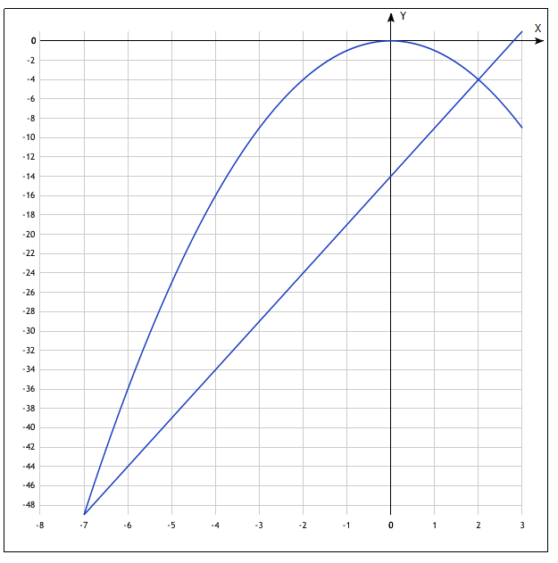

*y*(*x*)=5*x*−14

|  |  |
| --- | --- |
| **x** | **y** |
| -7 | -49 |
| 2 | -4 |