$$y=arc sin\left(x+1\right)-1$$

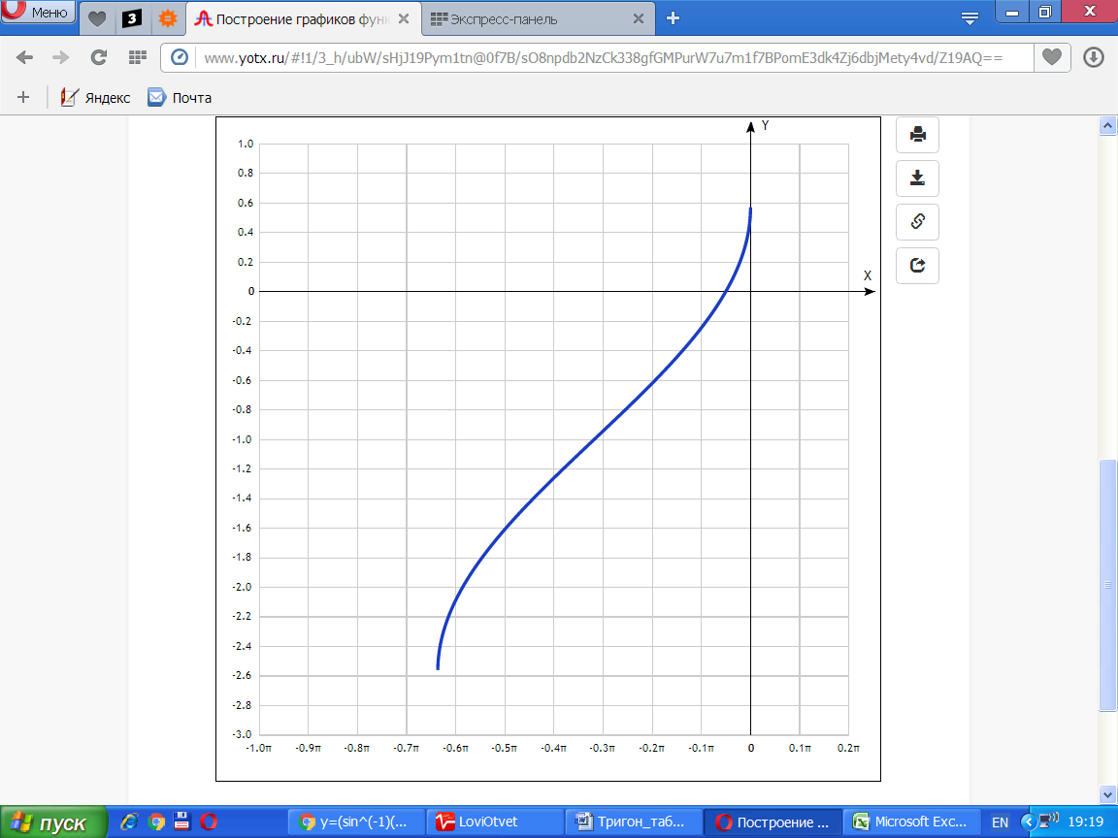

|  |  |
| --- | --- |
| **x** | **y** |
| -1.0π | - |
| -0.9π | - |
| -0.8π | - |
| -0.7π | - |
| -0.6π | -2.09 |
| -0.5π | -1.61 |
| -0.4π | -1.26 |
| -0.3π | -0.94 |
| -0.2π | -0.62 |
| -0.1π | -0.24 |
| 0 | 0.57 |
| 0.1π | - |
| 0.2π | - |