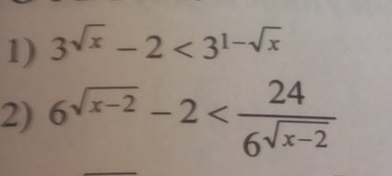



- + - +

-------------------|----------------------|-----------------|---------------->x

-1 0 3







- + - +

-------------------|----------------------|-----------------|---------------->x

-4 0 6

