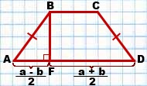

AD=a, BC=b

\[AF = \frac{{a - b}}{2}\]

\[FD = \frac{{a + b}}{2}\]