решита А, пожалуйста

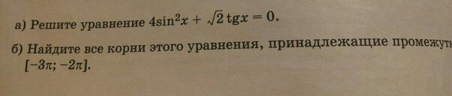

$$\begin{aligned}4{\text{sin}}^{2}x+\sqrt{2}⋅\text{tgx}=0\text{.} \text{tgx}=\frac{\text{sin}x}{\text{cos}x} \\ 4{\text{sin}}^{2}x+\sqrt{2}⋅\frac{\text{sin}x}{\text{cos}x}=0\text{.} \frac{4{\text{sin}}^{2}x⋅\text{cos}x+\sqrt{2}⋅\text{sin}x}{\text{cos}x}=0 \\ \frac{\text{sin}x⋅\left(4\text{sin}x⋅\text{cos}x+\sqrt{2}\right)}{\text{cos}x}=0\text{.} \frac{\text{sin}x⋅\left(2⋅\left(2\text{sin}x⋅\text{cos}x\right)+\sqrt{2}\right)}{\text{cos}x}=0 \\ \frac{\text{sin}x⋅\left(2⋅\text{sin}2x+\sqrt{2}\right)}{\text{cos}x}=0 \\ \begin{aligned}\left\{\text{sin}x=0 | \right.\left\{2\text{sin}2x+\sqrt{2}=0 | \right.\end{aligned} \\ \end{aligned}$$

