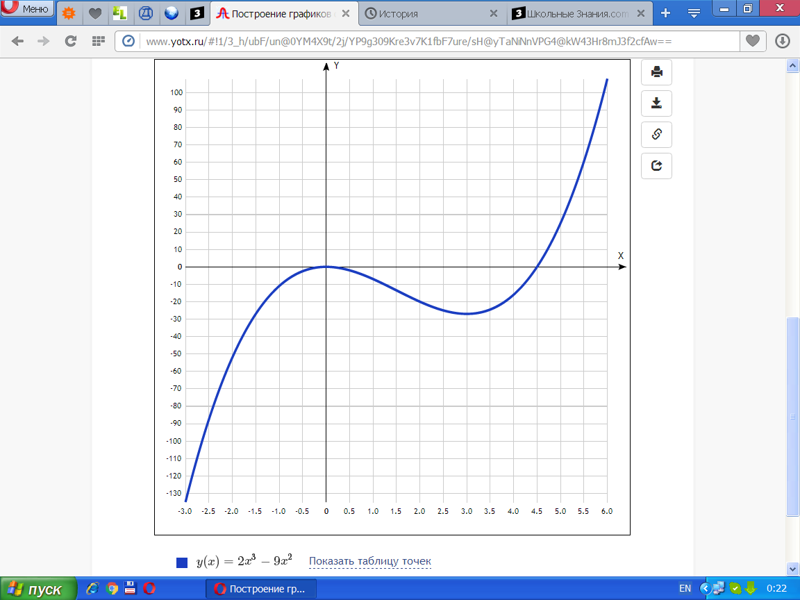

[Таблица точек](javascript:void(0);)

|  |  |
| --- | --- |
| **x** | **y** |
| -3.0 | -135 |
| -2.5 | -87.5 |
| -2.0 | -52 |
| -1.5 | -27 |
| -1.0 | -11 |
| -0.5 | -2.5 |
| 0 | 0 |
| 0.5 | -2 |
| 1.0 | -7 |
| 1.5 | -13.5 |
| 2.0 | -20 |
| 2.5 | -25 |
| 3.0 | -27 |
| 3.5 | -24.5 |
| 4.0 | -16 |
| 4.5 | 0 |
| 5.0 | 25 |
| 5.5 | 60.5 |
| 6.0 | 108 |