sin(3 x)+sin(5 x) = sin(4 x)

x = 2 pi n,   n element Z

x = 2 (pi n-(3 pi)\/8),   n element Z

x = 2 (pi n-pi\/8),   n element Z

x = 2 (pi n+pi\/8),   n element Z

x = 2 (pi n+(3 pi)\/8),   n element Z

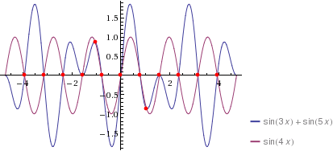

sin^5(x)-sin^3(x)+5 sin(x) cos^4(x)-10 sin^3(x) cos^2(x)+3 sin(x) cos^2(x) = 4 sin(x) cos^3(x)-4 sin^3(x) cos(x)

3 sin(2 x)+5 sin(4 x) = 8

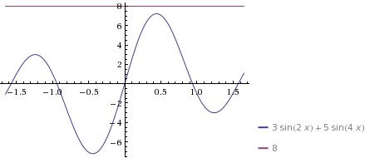

Нет ни одного решения.